http://www.trainingjournal.com/feature/articles-features-10-lessons-from-the-great-21st-century-recession/
Stephen Archer

Ten lessons from the great 21st century recession
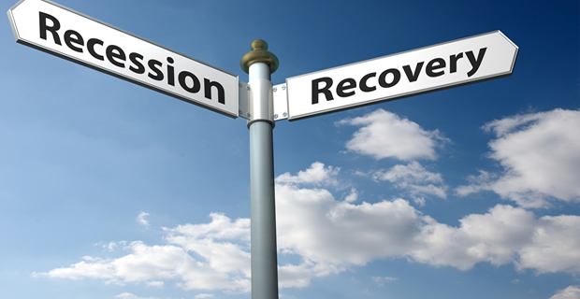
Great recession? Of course not greater than the Great War 100 years ago but let us not forget the lessons of this lesser skirmish since it arguably affected so many people. It was (and still is) the greatest economic crisis since 1929 - the so-called Great Depression. So what are the lessons for businesses?
1. The seven year economic cycle is a dead concept
It used to be the case and is supported by much evidence that economics tended to go in seven-year cycles: seven years climbing and seven years declining. We are now nearly six years on from Lehman's collapse though the current recession dates back to a year before that when LIBOR rates spiked suggesting a collapse in confidence in bank debt- amongst banks themselves. The interconnectivity of global markets and economies means that each economy is more likely to be affected by a global than domestic issue today. Warning signs may be around the globe, not around London, New York or Tokyo. We disregard warning signs at our peril, but warning signs are now far harder to discern.
2. We should embrace and even name recessions
Like the hurricanes that hit America we should name the recessions and connect better with them. This is not to say that we should wallow in them but this could I think help us avoid denial, increase understanding and reduce ignorance. We all suffer the consequences and can contribute to the recovery so let's keep recessions top of mind and not allow politicians to exploit them for their own ends.
3. Beware the heroes - they too often fall like Icarus
The bankers and even the governors of our economies were once seen as heroes. Years of growth seemed unstoppable; a new paradigm of continuous growth became accepted wisdom. More scepticism would have been wise but the words of caution that did exist were shouted down and suppressed. Looking back now at the unfettered free market dogma of Greenspan and even Adair Turner now looks like terrifying folly - because it was. Those that created huge wealth and helped economies grow did so with insufficient rigor and doubt. Yes, doubt, it' s a good thing; the check on hubris.
4. Beware the forecasters - complexity is defeating them
Though I may suggest naming recessions they will still be unreliably forecast just as weather forecasters so often fail. Economists of all hues lost huge credibility in the great recession. Few saw it coming and few predicted its course even after it started. This is a problem but for businesses the best hope is to focus on the economics and influences for the markets in which their industry operates. Each industry has own response to recessions. However, the global and macro economic factors cannot be forgotten.
5.We need to understand the new global order
'When China sneezes the US catches a cold and the rest of the world feels sniffly'. The global nature of capital flows and political impact is something to be concerned about. We are not able to vote for people who may determine our economic destiny. Those in business, especially big business need to take greater political and economic responsibility and do so responsibly.
6. When it's in the news the horse has bolted
The signs of the last recession were clear for many months, even years before it hit home. The speed of such events may be alarming but the lag from cause to effect needs to be better understood and managed. This recession started not with the consumer but with banks. More could have been done to insulate the consumer and business in future.
7. Understand why we are doing well
When it all goes wrong in the economy or business there is always an inquest. Such rigorous examination is rarely to be seen when things are going well. Such are the seeds of complacency and ignorance and yet when things are going well we have the time and funds to really understand why and in so doing understand the risks to sustaining success.
8. Look after the next generation
Humans have the selfish (survival gene) but survival and decadence with decay are not behaviours separated by much.
We tend to think of our children, as having to look to for themselves and to some extent this is correct and healthy. But we do not have to make it hard for them by ruining the resources that could be available to them if we took more care. This applies to business too.
9. Debt can be a bad thing, VERY Bad.
Debt for consumers and businesses can lead to ruin. In the great recession we saw debt ruin entire countries and severely damage their social fabric. (Iceland, Spain etc.) That debt in sovereign states is now even larger than it was in 2008 with little sign of reducing. Businesses depend on debt finance but have in recent years found it hard to get or undesirable to attain. The reality is that our thinking about debt wisdom needs careful clarification. The global debt model is broken but for businesses it's repairable.
10. Learn
There are some good books on the recession (e.g. Kenneth Rogoff) Read one or two of them. If nothing else you may come away trusting fewer people. That may not be such a bad thing.
Stephen Archer - business analyst and director of UK business consultancy, Spring Partnerships [www.springpartnerships.com]

